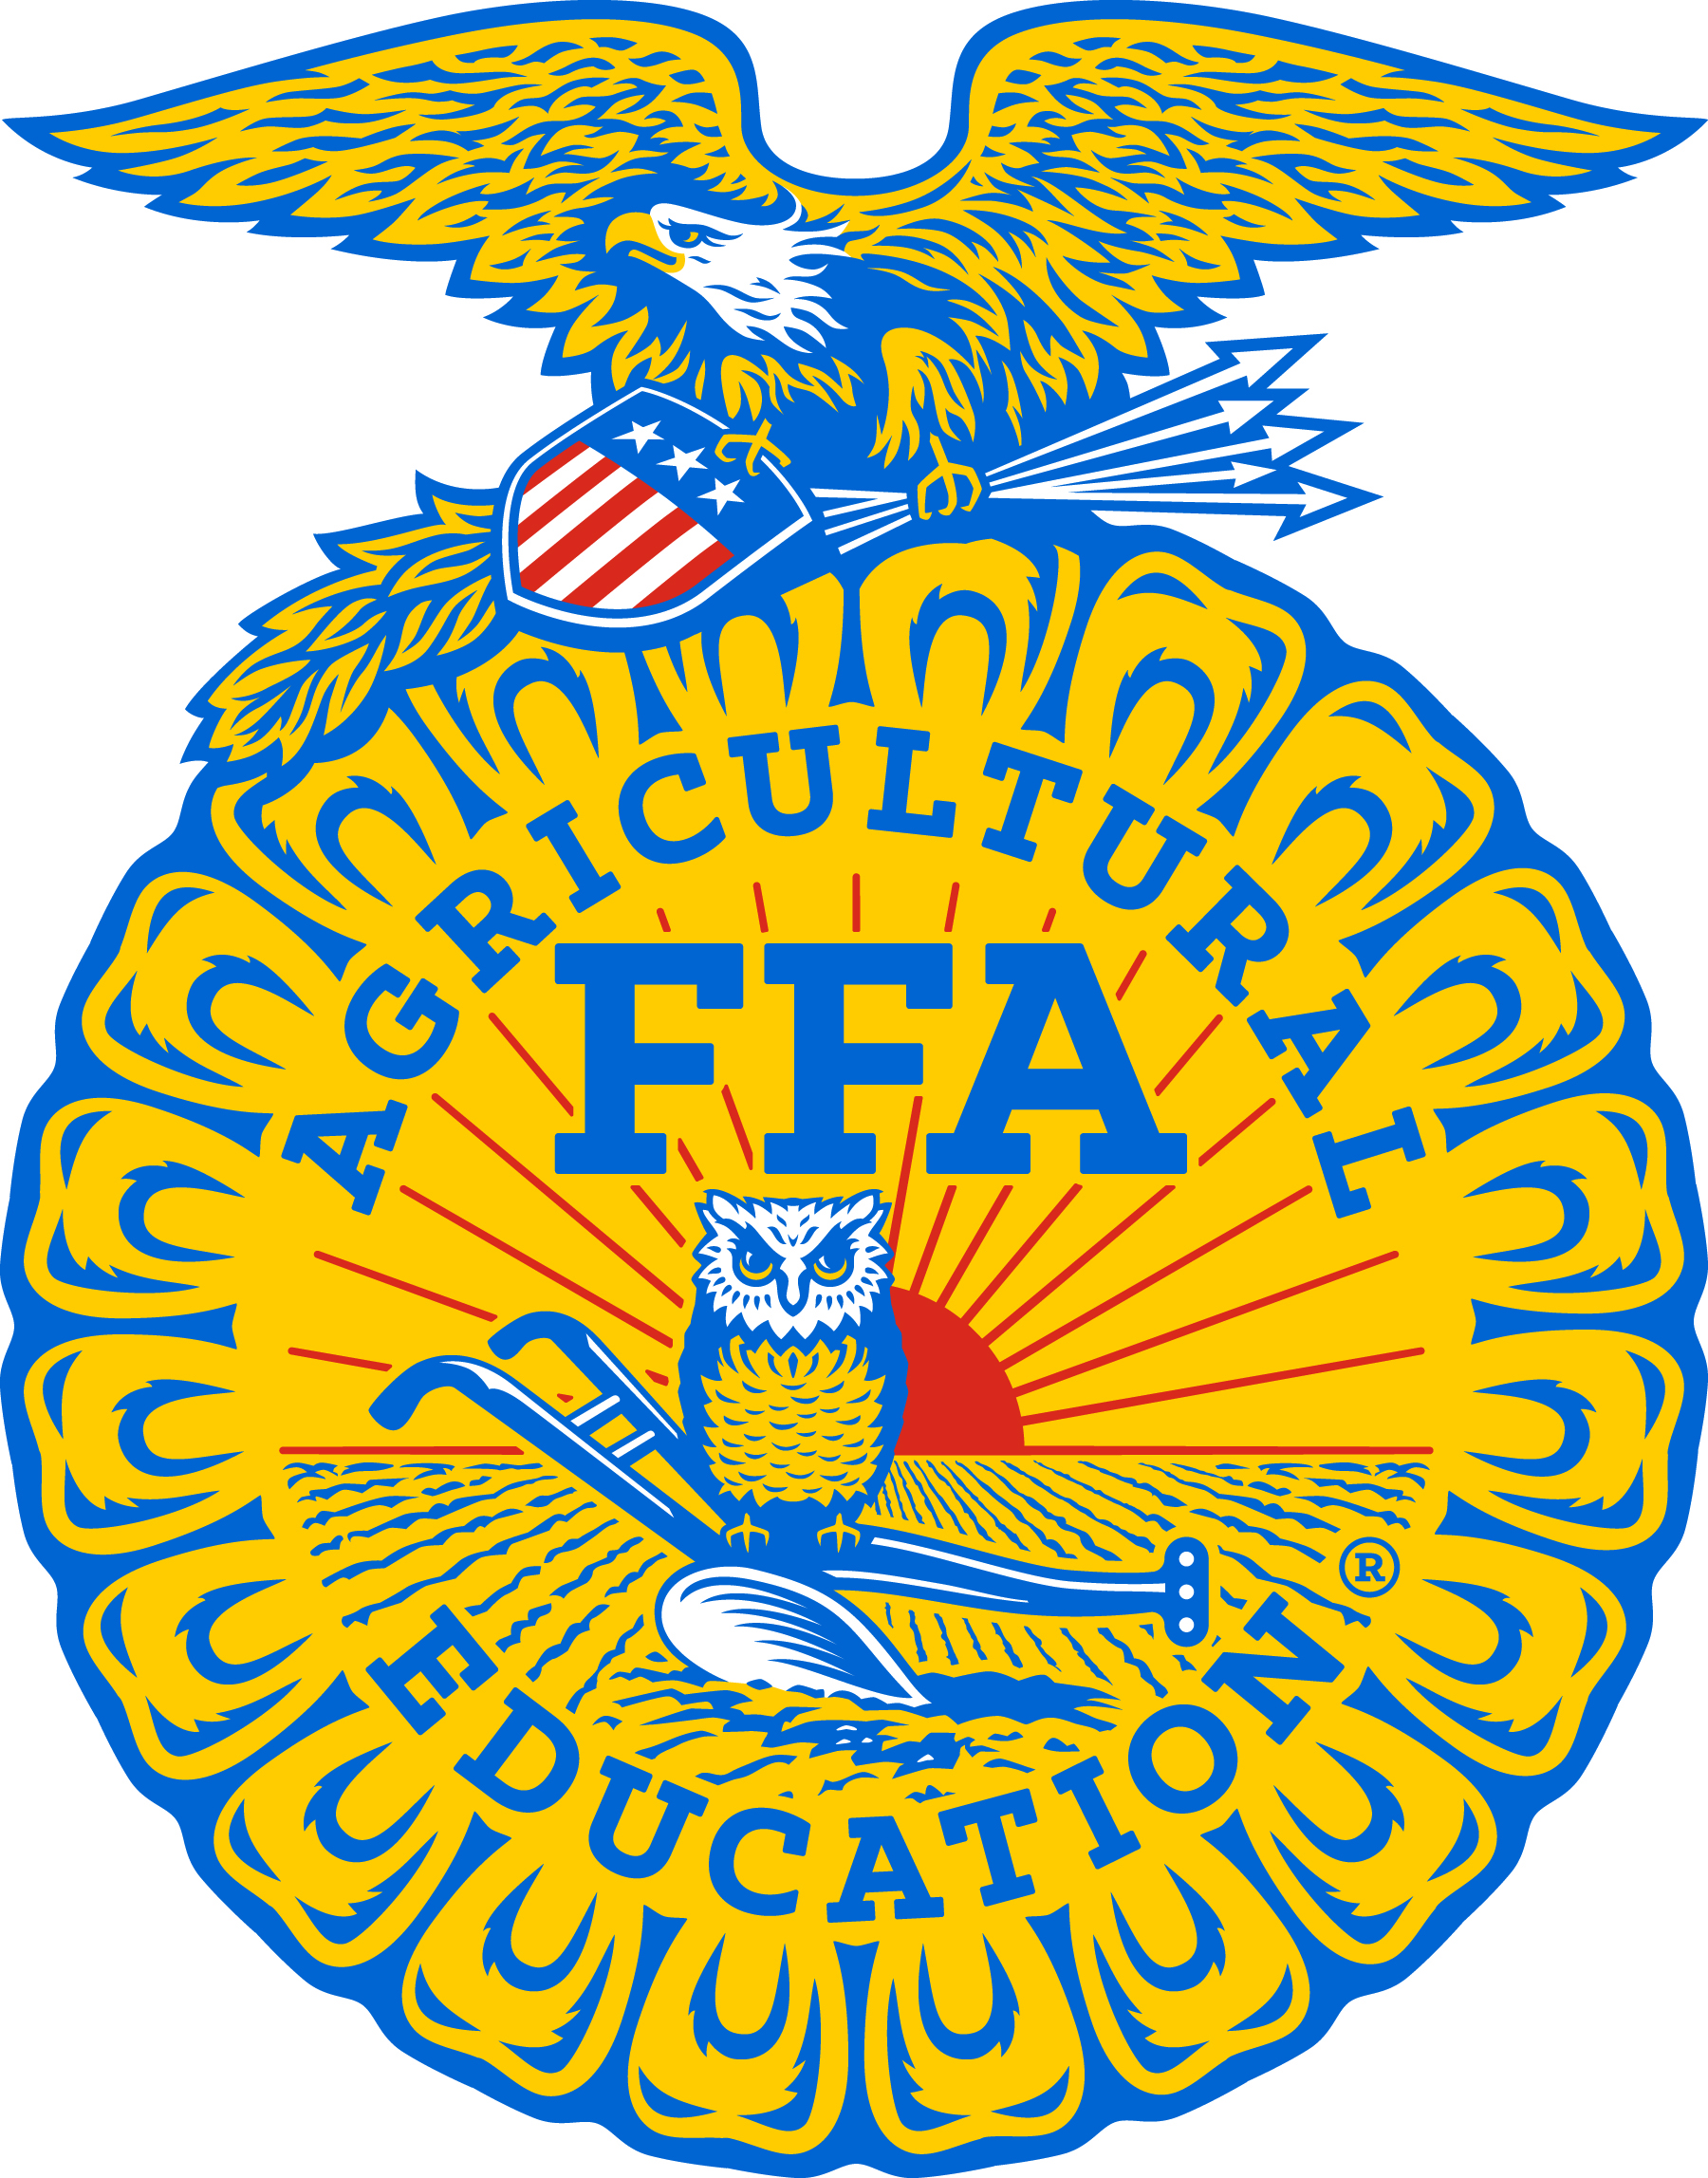
NEWS RELEASE FROM:
April Hamilton
Leadership and Program Manager
SD FFA
SDSU, Box 507
Brookings, SD 57007
april.hamilton@sdstate.edu

Award winner photos available to download at: https://drive.google.com/drive/folders/1Z_cwANNjsg9GJ_uctut_MaqyhfnwkXMo?usp=sharing

FFA Member Success at State Fair
Members of the South Dakota FFA participated in a wide range of educational activities during the 2021 South Dakota State Fair held September 1st-5th, in Huron. At the State Fair, there were 360 FFA members who exhibited 1224 exhibits. Results were as follows:

CHAPTER SWEEPSTAKES
1st place: McCook Central, 2nd Place: Beresford

CHAPTER EXHIBITS:
1st place –Wolsey Wessington, 2nd Place: Howard, 3rd Place: Bridgewater-Emery
Sponsored by Valley Queen Cheese.

TOP AG EXHIBITS CHAPTER:
1st place: McCook Central
Sponsored by Valley Queen Cheese, Milbank.

TOP AGRISCIENCE EXHIBITS:
1st Place: Landon Roling and Brode Dennis, McCook Central, 2nd Place: Erika Beck, Tri-Valley, 3rd Place: Zoe Dissing and Emery Pearson, Tri-Valley
Sponsored by Jakober Limousin.

BEEF SHOW
Champion Breeding Heifer – Jady LeDoux, Highmore
Reserve Champion Breeding Heifer – Wyat James, Estelline
Breeding Beef Showmanship – 1st Place: Wyat James, Estelline, 2nd Place: Taylor Harriman, Parker, 3rd Place: Mattisyn Keppen, Sioux Valley

Champion Market Steer – Ty Bergh, Florence
Reserve Champion Market Steer – Kaitlyn Micheel, Huron (no photo)
Champion Market Heifer – Kai Thomsen, Madison Central (no photo)
Reserve Champion Market Heifer – Drew Pederson, Garretson (no photo)
Market Beef Showmanship – 1st Place: Drew Pederson, Garretson, 2nd Place: Sarah Welch, Garretson, 3rd Place: Kai Thomsen, Madison Central

Breeding and Market Beef Showmanship sponsored by Jakober Limousin.

SWINE SHOW
Champion Market Gilt – Preston Mattheis, Parkston
Reserve Champion Market Gilt – Lacie Weber, Rutland
Market Gilt Showmanship- 1st Place: Baylee Schoenfelder, Parkston, 2nd Place: Rylee Schultz, Bridgewater-Emery, 3rd Place: Lacie Weber, Rutland
Champion Market Barrow – Baylee Schoenfelder, Parkston
Reserve Market Barrow – Tanner Calmus, Howard
Market Barrow Showmanship – 1st Place: Jovie Wirt, Lennox Sundstrom, 2nd Place: Melanie Calmus, Howard, 3rd Place: Ashton Ross, Parker
Swine Showmanship awards sponsored by Thompson Family.

SHEEP SHOW
Champion Breeding Ewe – Kassandra Knutson, Viborg-Hurley
Reserve Champion Breeding Ewe – Carissa Scheel, Wessington Springs
Champion Ram – August Anderson, Faulkton
Reserve Champion Ram– Kassandra Knutson, Viborg-Hurley
Breeding Sheep Showmanship – 1st Place: Josie Nold, Brookings, 2nd Place: Olivia Newell, Lennox Sundstrom, 3rd Place: Bailey Weegar, Viborg-Hurley

Champion Market Lamb – Cody Larson, Brookings
Reserve Champion Market Lamb – Elizabeth Albrecht, Howard
Market Lamb Showmanship – 1st Place: Raina Johnson, 2nd Place: Kody Goehring, 3rd Place: Elizabeth Albrecht, Howard
Breeding and Market Sheep Showmanship sponsored by Knutson Suffolks

DAIRY GOAT SHOW
Champion Doe- Oakleigh Reis-Elwood, Chamberlain
Reserve Champion Doe- Brityn Davies, Lake Preston
Champion Milking Doe- Trevon Cross, Garretson
Reserve Champion Milking Doe- Makayla Cross, Dell Rapids
Overall Champion Dairy Goat- Trevon Cross, Garretson
Dairy Goat Showmanship-1st Place: Kyle Hamilton, Hitchcock-Tulare, 2nd Place: Trevon Cross, Garretson, 3rd Place: Brityn Davies, Lake Preston
Dairy Goat Awards sponsored by Boldt Farms

MEAT GOAT SHOW
Champion Breeding Meat Goat – Tate Miller, Howard
Reserve Champion Breeding Meat Goat – Ashlyn Tangen, Sioux Valley
Breeding Meat Goat Showmanship – 1st Place: Kahli Gall, Freeman, 2nd Place: Emma Pierce, Estelline, 3rd Place: Ashlyn Tangen, Sioux Valley
Champion Market Meat Goat- Tate Miller, Howard
Reserve Champion Market Meat Goat- Tate Miller, Howard
Meat Goat Showmanship-1st Place: Danika Gordon, Sturgis, 2nd Place: Derek VanAsselt, Tri-Valley, 3rd Place: Tanner VanAsselt, Tri-Valley
Breeding and Market Meat Goat Showmanship sponsored by Lazy J Bar Ranch

RABBIT SHOW
Best of Show (Grand Champion Rabbit) – Riley Gall, Freeman
Reserve Best of Show (Reserve Champion Rabbit) – Brianna Gilchrist, Winner
Rabbit Showmanship – 1st Place: Hunter Masterson, Menno, 2nd Place: Michael Freeman, Ethan, 3rd Place: Breanna Gilchrist, Winner
Rabbit Showmanship sponsored by Woehl’s Rabbits. Best of Show and Reserve sponsored by Mark and Staci Schloe.

DAIRY SHOW
Supreme Champion Female – Sydney Triebwasser, Sushine Bible Academy
Champion Holstein Female – Neil Haase, Parker
Senior Champion Holstein – Bailey Fairbanks, Winner
Junior Champion Holstein Heifer – Neil Haase, Parker
Junior Reserve Champion Holstein Heifer – Natalie Haase, Parker
Champion All Other Breed Female – Sydney Triebwasser, Sunshine Bible Academy
Senior Champion All Other Breed – Sydney Triebwasser, Sunshine Bible Academy
Senior Reserve Champion All Other Breed – Sydney Triebwasser, Sunshine Bible Academy
Junior Champion All Other Breed Heifer – Brayton Plucker, Lennox-Sundstrom
Junior Reserve Champion All Other Breed Heifer – Skyler Plucker, Lennox-Sundstrom
Dairy Showmanship: 1st Place: Grace Norling, Beresford, 2nd Place: Jacob Post, Sioux Valley, 3rd Place: Ryker Bradley, McCook Central

Dairy Showmanship sponsored by Valley Queen Cheese.

2022 ROUND ROBIN SHOWMANSHIP (sponsored by Odden Cattle Company, Ree Hights)
1st Place – Drew Pederson, Garretson
2nd Place – Josie Nold, Brookings
Round Robin Showmanship sponsored by Odden Cattle Company.

Funding for these events are made possible as a special project of the SD FFA Foundation. FFA Livestock Show premiums are sponsored Hart Angus, Livestock Specialists Inc., Horizon View Farms, TexKota Panel, and SD Cattelmen’s Foundation. Exhibitors show t-shirts are sponsored by: 605 Sires; Cargill; Cob Creek Cattle; Custom Genetic Solutions Dakotaland Feeds; DeJong Ranch; Gullickson Family Livestock; Lazy J Bar Ranch; Midwest Veterinary Service; Beef Bucks Inc.; SD Lodge for Fraternal Order of Police; Sleepy Hollow Farm; Stangl Shorthorns; Texkota Panel; Horizon View Farm; Cattle Business Weekly; Whetstone Commodities; Wagner Herefords; Hart Angus; and Livestock Specialists.

